Harvel Electric

It is the best company which provides you the best electric appliances all over the world.

Our Products

Our products are geniune we import our products from malysia, nigerya, japan, indonesia, america & much more.

Claim Warranty

You can claim waranty at your nearest shop we provide our best make you satisfy for our products. Broken appliances will not be claimed.

Information Technology Solutions

Key Features

AddWash

Bubble Soak

Bubble technology

Child Lock

IRON-BLACK+DECKER-NI-JV850

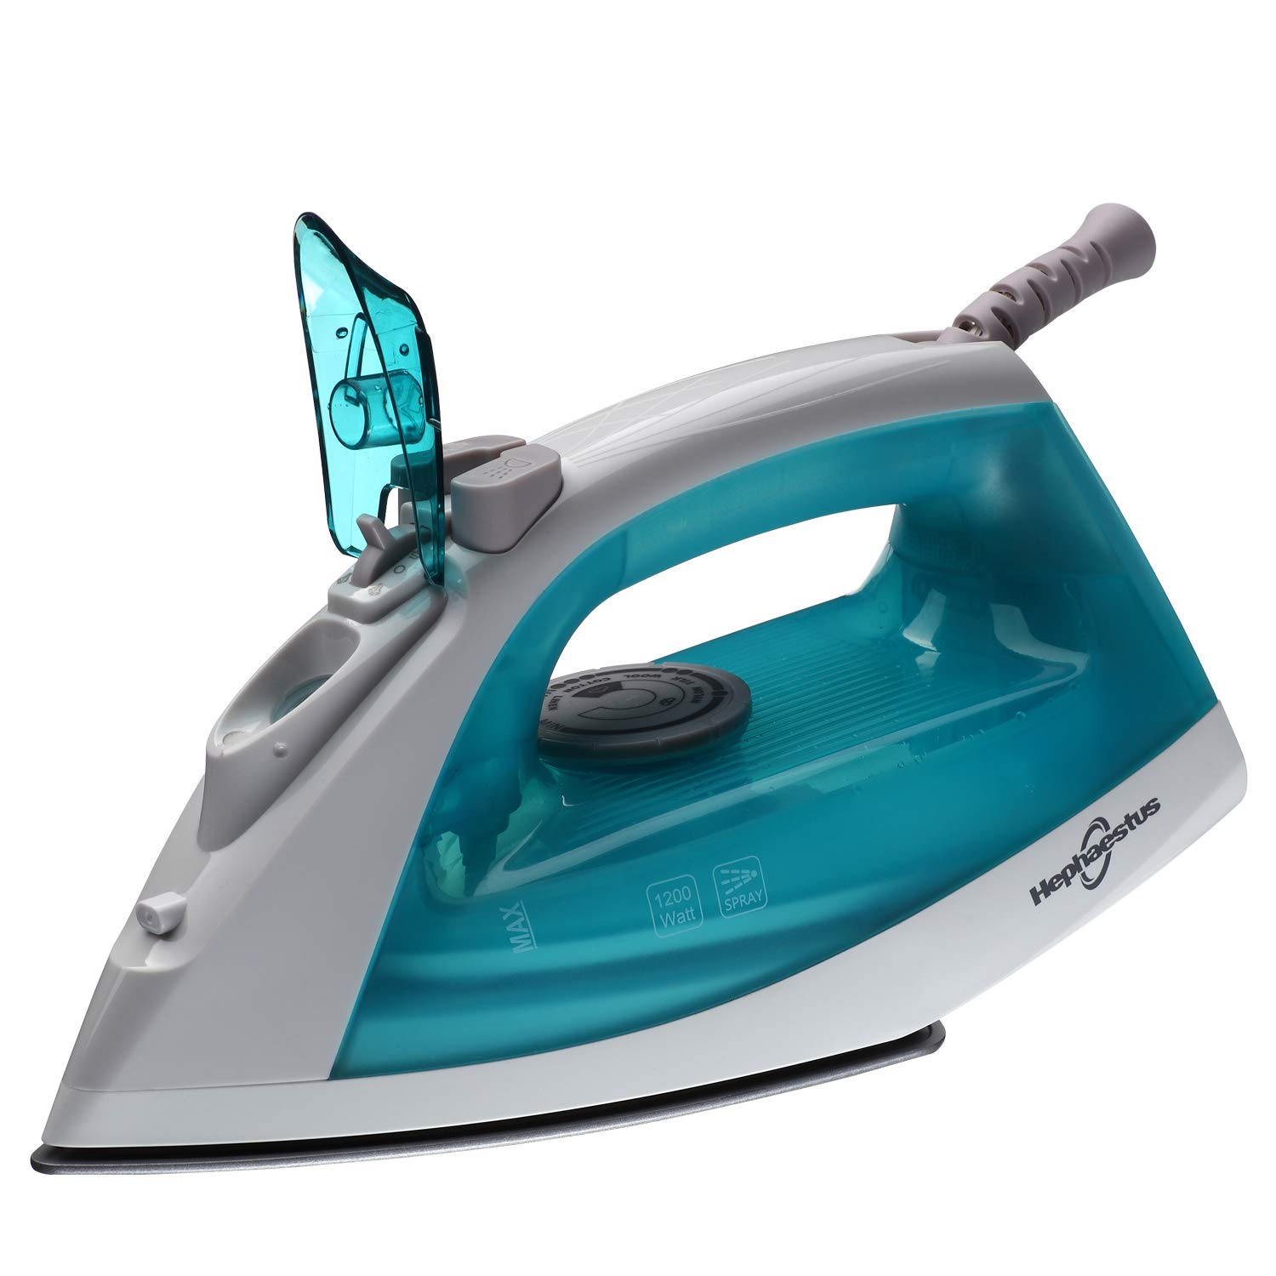Delay End

Diamond Drum

Last Memory

Inverter Motor

Quick Wash

Smart Check

Spin Speed 1400 rpm

Super SpeedSmartphone App

**Features**

* Easy and Stable Glide
* Easy to Grip, Ergonomic Handle
* Anti-Calcium
* Desalting Performance
* Anti-Deposition System
* Separate Button for Water Spray
* Barefoot
* Steam Hole System
* Self Cleaning (Forced Drainage)
* Steaming the Moment
* Heavy Duty Design for Comfortable Ironing
* Big Soleplate, Quick Result
* Jet Steam Vertical Vapor Shock System
* Volume Setting
* Water Tank
* 360 Degree Scratch Pad – Alumite
* Precision Tip
* Anti-Drip System
* Vertical Steam
* Easy Maintenance & Long-lasting
* U-Shape Form
* Ceramic Coating
* Durable
* Easy Operation
* Alumite Shoe Material
* Made in Japan

|  |  |
| --- | --- |
| **Weight**  **8 KG** | 20 kg |
| **Brands**  **BLACK+DECKER** | [Panasonic](https://www.alfatah.com.pk/brands/panasonic/) |
| **Electronics Type**  **IRON** | [Iron](https://www.alfatah.com.pk/electronics-type/iron/) |

|  |  |  |  |
| --- | --- | --- | --- |
|  | |  | |
| **Power** | | [400W](https://www.alfatah.com.pk/power/920w/) | |
| **Weight** | | 20 kg | |
| **Power** | | [920W](https://www.alfatah.com.pk/power/920w/) | |
| **Weight** | |
|  | |  | |
| The Smarter, Quietest Clean. | |  | |
| LG Hom-Bot is a truly intelligent robotic vacuum with wi-fi capabilities, giving users total control using a smartphone. And while Hom-Bot’s cleaning technology makes people take notice, thanks to an innovative design that absorbs vibrations and reduces noise, it’s the quietest robot vacuum on the market on non-carpeted floors.* | | [C onventional](https://www.alfatah.com.pk/technology/conventional/) | |
| The Smarter, Quietest Clean. | | [Wall Mounted Split](https://www.alfatah.com.pk/air-conditioner-type/wall-mounted-split/) | |

Harvel-Electric

Life is easy with harvel

Harvel - Electric